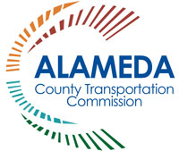
2018 Proposition 6 and Senate Bill 1 Communications Toolkit

TALKING POINTS
Proposition 6 (Prop 6) and Senate Bill 1 (SB 1)

SB 1 FUNDING AT RISK ON NOVEMBER BALLOT WITH PROPOSITION 6
In April 2017, Governor Jerry Brown signed into law SB 1, the Road Repair and Accountability Act of 2017. This landmark funding program increased the gas tax, diesel tax and vehicle registration fees to invest approximately $5.4 billion annually in state and local roads, goods movement, public transit and active transportation programs.

SB 1 provides a new revenue stream to support projects currently funded by Measure BB—a measure approved overwhelmingly by Alameda County voters and is anticipated to generate over $8 billion for essential transportation improvements in every city and throughout the County, serving as a down payment to attract regional, state and federal funds to deliver projects, support local jobs and the economy. Together, Measure BB and SB 1 can deliver projects faster.

The measure to repeal SB 1 through a constitutional amendment will be on the November 2018 ballot as Prop 6. If successful, it will:
- Eliminate over $40 million per year in road maintenance funds from city and county budgets.
- Eliminate all SB 1 funding designated for state highways.
- Eliminate more than $30 million per year in transit operations and maintenance funds in Alameda County.
- Require any measure enacting specified taxes or fees on gas or diesel fuel, or on the privilege to operate a vehicle on public highways, to be submitted to the electorate
for approval.
- Potentially lower future transportation tax revenues.
- Alameda CTC projects on highways, rail, goods movement, roads, bridges, trails and pedestrian safety projects would be delayed indefinitely, including:
  - Express Lane expansions
  - Port modernization and efficiency and safety projects
  - Local community rail safety crossing improvements
  - East Bay Greenway, Bay Trail, Iron Horse Trail and Niles Canyon trails
  - Interregional rail service expansion
  - Arterial improvements throughout the county including Dublin Boulevard extension, East 14th/Mission Boulevard, San Pablo Avenue and others throughout the County
  - Local streets and pedestrian safety projects

The bottom line is that if Prop 6 passes, critical road rehabilitation, maintenance and safety projects would be cut in Alameda County and throughout California. Alameda CTC and transportation, business, labor, and other organizations have taken oppose positions on
Prop 6.
WHY THIS IS IMPORTANT:
SB 1 increased the state gas tax for the first time in 23 years, along with increases in certain vehicle registration fees to raise over $5 billion annually for a wide variety of transportation improvements described below. There is a measure on the November 2018 ballot, Prop 6, that would repeal SB 1.
- Fixing potholes, repairing bridges and improving transit is a high priority for transportation funding. In Alameda County, 28% of roads are at risk, failing or in poor condition, and another 27% are good or fair and will need maintenance within the next five years. This means that more than half of roads throughout the County have immediate or near-term maintenance needs.
- Californians currently pay $762 per year in additional vehicle repair costs because of the poor condition of our roads.
- SB 1 will generate more than $50 billion over the next decade, split between state and local roads, highways, and transit systems.
- There hasn’t been an investment in transportation like this in more than two decades.
- California’s roadways are deteriorating significantly due to high traffic, lots of heavy freight, weather and aging infrastructure, so our focus is on maintenance and rehabilitation of the existing system that will provide Californians with a transportation system that is safe, sustainable and efficient.
- SB 1 includes competitive funding for congested road and highway segments
($250 million per year) and trade corridors ($300 million per year) and provides
$100 million annually for the Active Transportation Program, which encourages active modes of transportation like biking and walking.
  - In May 2018, Alameda CTC was awarded over $187 million in SB 1 trade corridor funds for improvements at the Port of Oakland (7th Street Grade Separation East and Freight Intelligent Transportation Systems (FITS).
- Investing in our infrastructure means safer roads for California drivers and tens of thousands of good paying jobs fixing our roads.
  - The American Road and Transportation Builders Association estimates that SB 1 will generate at least $182.6 billion in increased economic activity and benefits for California residents and businesses over the next 10 years, averaging
$18.3 billion per year.
  - SB 1 will support an additional 650,000 job years over the next 10 years (defined as employment for one person during one year; for example, if one person is hired in the manufacturing sector and remains in her position for five years, this is counted as five job years). (California State Association of Counties SB 1 Frequently Asked Questions and Answers)
  - SB 1 will support the repair, repaving and reconstruction of over 84,000 lane miles on nearly 19,000 miles of roadway, including work on over 18,300 lane miles of urban interstate and 7,000 lane miles of rural interstate over 10 years.

SB 1 NEW TRANSIT FUNDING
More than $58 million is estimated in FY2018-19 in state transit funding for Alameda County transit operators including over $34 million per year in new transit operations and maintenance funding as shown on Table 1.

Table 1
Alameda County Transit Operators | Existing State Transit Operating Funds**  ($ x million) | New SB 1 Operating Funds  ($ x million) | New SB 1 State of Good Repair Program  ($ x million) | Total New SB 1  Augmentation  ($ x million) | Overall Total  ($ x million)
AC Transit | $8,309 | $8,309 | $3,149 | $11,459 | $19,768
BART | $16,098 | $16,098 | $6,102 | $22,201 | $38,299
LAVTA | $147 | $147 | $56 | $202 | $349
Union City | $45 | $45 | $17 | $62 | $107
ACE (Alameda County) | $99 | $99 | $37 | $136 | $234
TOTAL | $24,698 | $24,698 | $9,361 | $34,060 | $58,758

LOCAL STREETS AND ROADS FUNDING
- SB 1 enables cities and counties to address significant maintenance, rehabilitation and safety needs on the local streets and road system to fill potholes, repairs cracks and ensure bridge safety. See Table 2.
- SB 1 generates over $5 billion annually for state and local transportation improvements. Cities and counties are slated to receive $1.5 billion annually at full implementation of SB 1 (in 2020).
- SB 1 provides funding for every community to rehabilitate, repair, and maintain local streets and roads, to make critical, life-saving safety improvements, to repair and replace aging bridges and culverts, to reduce congestion and increase mobility options, including bicycle and pedestrian facilities.
  - There are 96 projects in Alameda County that have been approved by the California Transportation Commission: 87 city projects and 9 county projects. Refer to Attachment A for the list of projects submitted to the California Transportation Commission for approval in FY2018-19 (“Adoption of the Fiscal Year 2018-19 Road Maintenance and Rehabilitation Account Local Streets
and Roads Funding Initial Report of Eligible Cities and Counties, Resolution
G-18-33”).
  - Collectively the jurisdictions in Alameda County will receive a 70% increase in NEW money each year for road repairs, which is almost half a billion dollars in
10 years that will be eliminated if SB 1 is repealed.

Table 2: Local Streets and Roads (LSR) FY2018-19 and 10-year Estimate by Jurisdiction
Jurisdiction in  Alameda County | Existing State Roads Funding (HUTA)¹ | New SB-1 Funding (FY2018-19)² |  | Combined Total (FY2018-19) |  | Estimated 10 year total³
Alameda | $1,854,242 | $1,343,689 |  | $3,197,931 |  | $15,403,889
Albany | $447,765 | $320,223 |  | $767,988 |  | $3,670,998
Berkeley | $2,800,936 | $2,032,474 |  | $4,833,410 |  | $23,300,037
Dublin | $1,344,761 | $972,025 |  | $2,316,786 |  | $11,143,177
Emeryville | $280,129 | $198,663 |  | $478,792 |  | $2,277,449
Fremont | $5,342,973 | $3,886,879 |  | $9,229,852 |  | $44,558,712
Hayward | $3,708,698 | $2,694,683 |  | $6,403,381 |  | $30,891,521
Livermore | $2,060,121 | $1,493,876 |  | $3,553,997 |  | $17,125,614
Newark | $1,050,138 | $758,193 |  | $1,808,331 |  | $8,691,833
Oakland | $9,839,545 | $7,167,109 |  | $17,006,654 |  | $82,162,873
Piedmont | $268,465 | $190,154 |  | $458,619 |  | $2,179,903
Pleasanton | $1,754,451 | $1,270,892 |  | $3,025,343 |  | $14,569,353
San Leandro | $2,049,944 | $1,486,453 |  | $3,536,397 |  | $17,040,518
Union City | $1,707,285 | $1,236,485 |  | $2,943,770 |  | $14,174,915
County of Alameda | $25,838,702 | $17,231,773 |  | $43,070,475 |  | $197,542,966
TOTAL | $60,348,155 | $42,283,571 |  | $102,631,726 |  | $484,733,755
Notes:
1. Highway User Tax Account (HUTA) Cities and County receive Allocations directly from State
2. Data Source: http://californiacityfinance.com/
3. Estimates a 3% per year growth rate

- SB 1 gives cities and counties an opportunity to catch up on years of unfunded maintenance needs that have plagued our roadways and cost drivers for years, in addition to allowing local Measure BB dollars to have more buying power.
- SB 1 funding allows cities and counties to accelerate the delivery of projects that have been delayed due to a lack of funding. Our goal is to maintain roads and address small problems immediately, so they don’t get worse and cost more to fix later.
- Alameda CTC has already identified a list of projects that will benefit from SB 1 by leveraging Measure BB dollars as shown on Table 3 below.

Table 3: List of Projects funded by Measure BB that are Eligible for SB 1 Funding
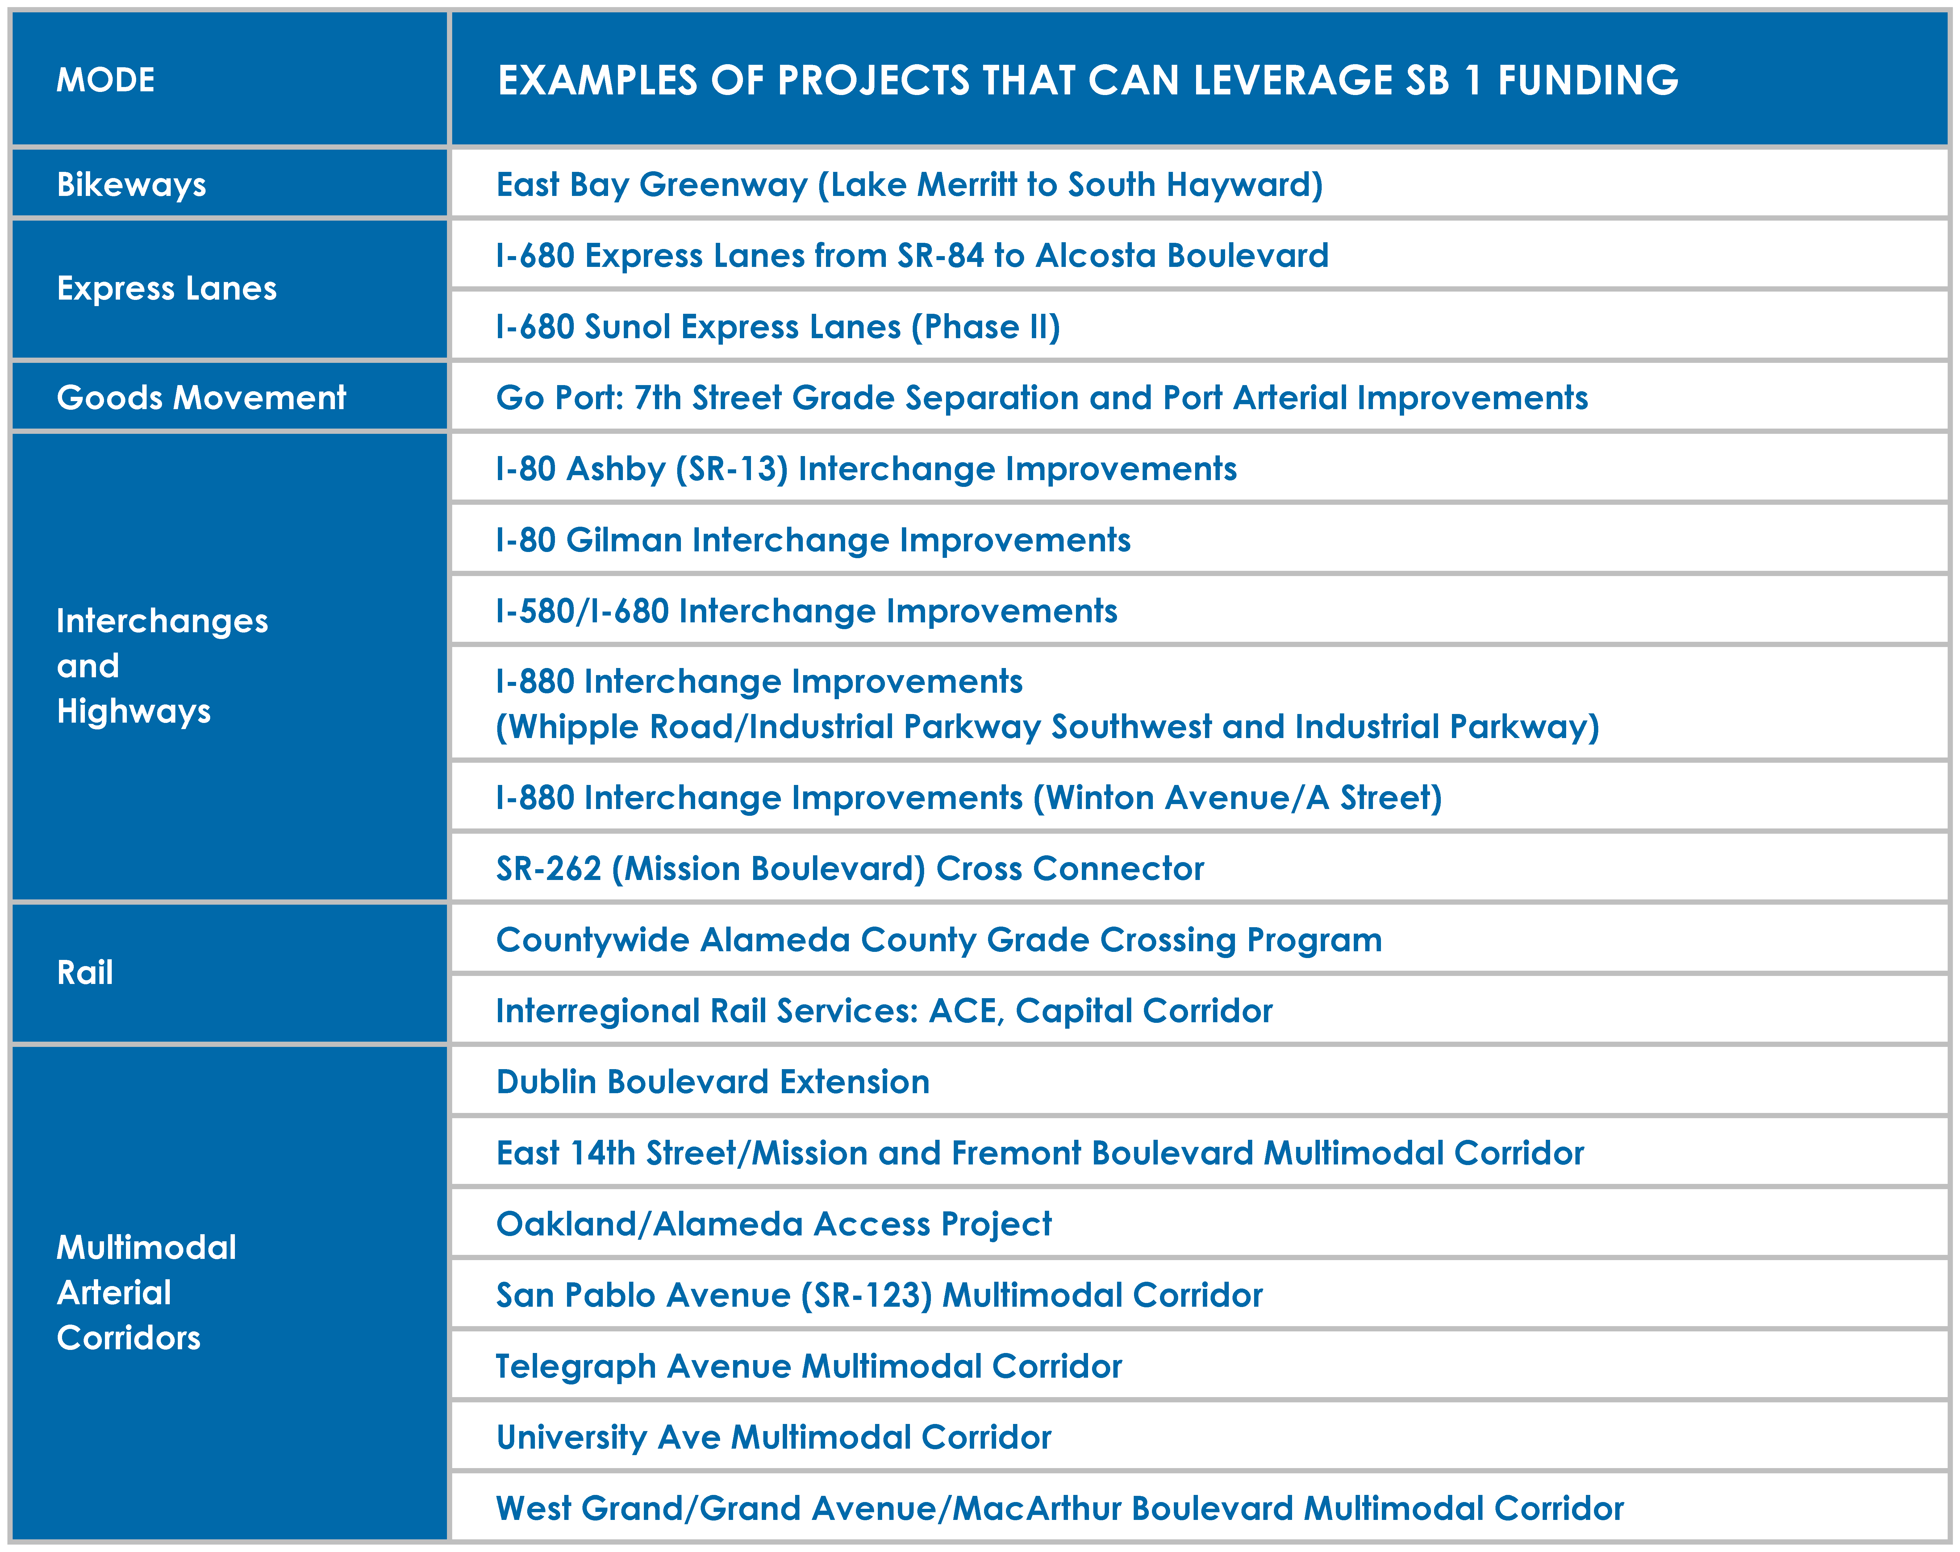

- SB 1 includes accountability and transparency measures. Cities and counties will publicly adopt project lists at the start of every fiscal year and provide year-end reporting on completed projects.
- Other accountability provisions ensure these funds only go to transportation improvements; the money cannot be diverted for non-transportation purposes. This was further strengthened by passage of Prop 69 in June 2018, ensuring that all funds go directly for transportation purposes as defined in SB 1 and cannot go to the state general fund.

HERE ARE SOME OTHER FACTS ABOUT SB 1
- The California Department of Finance calculated that the average cost to support SB 1 to motorists is less than $10/month.
  - Registration: Nearly 50% of all registered vehicles in California are valued at less than $5,000. 40% are valued at less than $25,000. Thus, the average annual amount for vehicle registration is approximately $48.
  - Fuel: California’s 26 million licensed drivers consume 15.5 billion gallons per year. At 577 gallons per driver, multiplied by 12 cents per gallon, the SB 1 fuel cost is $69.24 per driver.
  - The annual average cost per driver is:
    - Vehicle Registration $47.85
    - Fuel $69.24
    - Total $117.09 per year OR $9.76 per month
- Article XIX of the California Constitution already protects the gasoline excise tax and vehicle registration fees, as well as a portion of the sales tax on diesel, and dedicates them to transportation purposes. This accounts for about 60% of the revenues generated by SB 1. Prop 69, a constitutional ballot measure which was approved by the voters in June 2018, extends these same constitutional protections to the remaining 40% of new revenues generated by SB 1. It’s also important to remember that all gas tax monies that were loaned in prior decades to the General Fund will have been repaid under SB 1.
- SB 1 is a job creator. The White House Council of Economic Advisors found that every $1 billion invested in transportation infrastructure supports 13,000 jobs a year. With the $5 billion annually planned from SB 1, this measure will put 650,000 people to work rebuilding California over the next decade.
- A percentage of the existing gas tax revenue related to fuel sales from boats, agricultural equipment, and other off-highway vehicles (quads, dirt bikes) has always gone toward supporting infrastructure related to these economic and recreational activities. The percent of gas tax revenues collected from these sources under SB 1 is 2%.
- SB 1 directs $7 million (one-tenth of 1% of total SB 1 revenues) to California State Universities and University of California transportation research institutions for research directly related to improving transportation technology, practices, materials and impacts to the environment.
- All outstanding transportation (gas tax) loans are being repaid by the General Fund. In fact, the FY2016-17 state budget already started to repay those loans. SB 1 requires all loans to be repaid by 2020.
- No funds raised from SB 1 will be used to fund high-speed rail. California’s state-maintained transportation infrastructure will receive roughly half of SB 1 revenue:
$26 billion. The other half will go to local roads, transit agencies and an expansion of the state’s growing network of pedestrian and bicycle routes. There is no remaining balance that could be used for the high-speed rail project. A full overview of how the funds are allocated can be found here (http://rebuildingca.ca.gov/overview.html).

BACKGROUND ON CRITICAL NEED FOR INVESTMENT
- The 2016 California Statewide Local Streets and Roads Needs Assessment found that the condition of local streets and roads on average was “at risk,” meaning that without an infusion of new funding, local transportation infrastructure was failing.
- California roads continue to rank in the top five worst in the country. For too long we’ve underinvested in our transportation network, and SB 1 helps ensure Californians are driving on safe roads. Conditions of infrastructure are included in these reports:
  - American Society of Civil Engineers 2016 report
  - Business Insider 2017 report
- Local streets and roads faced a funding shortfall of $78 billion over 10 years to bring the system into a state of good repair. Caltrans also faced a $59 billion backlog in deferred maintenance without SB 1.
- A total of 25% of California bridges show significant deterioration and need to be repaired or replaced (TRIP August 2016 report).

Source: California State Association of Counties: SB 1 Frequently Asked Questions and Answers http://www.counties.org/sites/main/files/file-attachments/sb_1_qa_for_local_agency_final.pdf
Ibid
Source: The Economic Impacts of Senate Bill 1 on California, American Road and Transportation Builders Association (ARTBA), page 4
Source: California State Association of Counties http://www.counties.org/
Source: California State Association of Counties: SB 1 Frequently Asked Questions and Answers http://www.counties.org/sites/main/files/file-attachments/sb_1_qa_for_local_agency_final.pdf
Ibid

