This checklist is designed to assist the applicant and jurisdiction staff identify and assess a range of Complete Streets-related needs in the vicinity of each development. These needs, if addressed, would better serve the multimodal transportation needs of those coming and going from the site and the surrounding area. The checklist is to be completed during the pre-application phase, but can be used as a reference throughout the development and design of the project. Following completion of the checklist, staff will identify and document project modifications for further evaluation and discussion.
Project Name_________________________________________________________________ Project Description / Project Type:
Project Location ______________________________________________________________
Project Manager______________________________________________________________
Anticipated construction date____________________________________________________

Pre-Application Phase

Project Description
- What are the proposed land uses (check all that apply)?
□ residential □  commercial /mixed use □ industrial □ civic/institutional □ other ___________________________________________________
- What are the major trip generators near the project site, if any? (existing and future)
  - Schools □yes □no
  - Major employers □yes □no
  - Civic/community destinations □yes □no
  - Medium to high-density residential □yes □no
  - Senior centers/healthcare facilities □yes □no
  - Daily needs (grocery, retail, etc.) □yes □no
  - Other __________________________________________________

- Is the project site located on the path to/from nearby trip generators?
□yes □no
Explain: ____________________________________________________

- Based on the modal priority maps (available at https://alameda-ctc.maps.arcgis.com/apps/View/index.html?appid=2040175145de4305a5f59c6e82ca16c7), list the modal priorities on adjacent streets (check all that apply):

Adjacent Street 1 Name: __________________________________
Auto | □ First | □Second | □Other
Bicycle | □ First | □Second | □Other
Pedestrian | □ First | □Second | □Other
Transit | □ First | □Second | □Other
Trucks | □ First | □Second | □Other

Adjacent Street 2 Name: __________________________________
Auto | □ First | □Second | □Other
Bicycle | □ First | □Second | □Other
Pedestrian | □ First | □Second | □Other
Transit | □ First | □Second | □Other
Trucks | □ First | □Second | □Other

Adjacent Street 3 Name: __________________________________
Auto | □ First | □Second | □Other
Bicycle | □ First | □Second | □Other
Pedestrian | □ First | □Second | □Other
Transit | □ First | □Second | □Other
Trucks | □ First | □Second | □Other

Work with Transportation and Engineering Staff to fill out questions 5-8.
- Within the past five years, have there been any fatal or severe injury collisions within ¼ mile of the site? □yes □no
If yes, explain_______________________________________________
- Within the past five years, have there been any collisions within ¼ mile of the site involving pedestrians or bicyclists? □yes □no
- Have you observed other opportunities to improve safety performance? (based on field observation) □yes □no If yes, note:

If yes, explain_______________________________________________

Existing Physical Conditions

- What are the existing right-of-way elements adjacent to the project site? Use cross section graphic for each street adjacent to the site.
Adjacent Street 1: Street name _____________________________

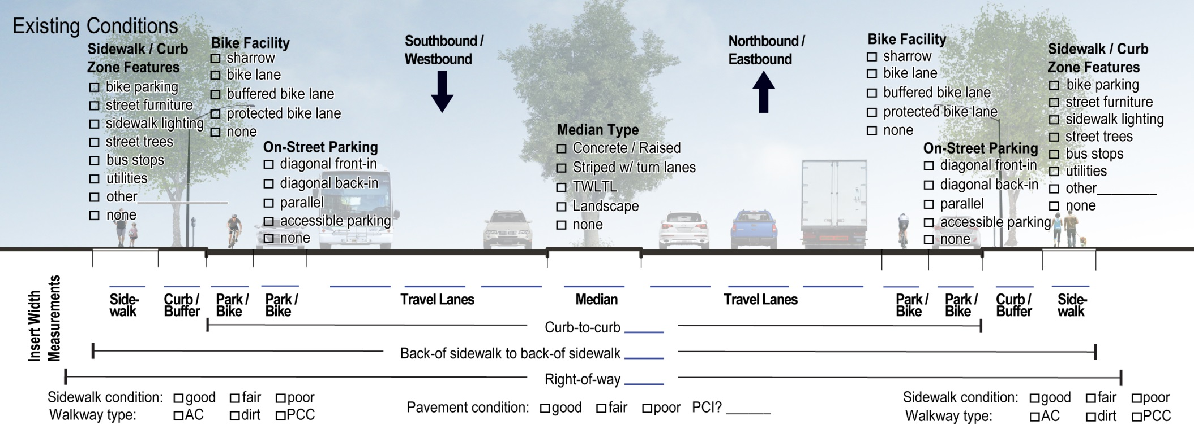
TWLTL = two-way left turn lane | AC = asphalt concrete | PCC = poured cement concrete | PCI = pavement condition index
Adjacent Street 2: Street name _____________________________
Adjacent Street 3: Street name _____________________________

Plans, Policies, Guidelines, and Standards
    - What are relevant ongoing or existing plans?
Plan | Identified Needs (yes or no)
 | Ped | Bike | Transit | Vehicular | Other
 | □ yes □ no | □ yes □ no | □ yes □ no | □ yes □ no | □ yes □ no
 | □ yes □ no | □ yes □ no | □ yes □ no | □ yes □ no | □ yes □ no
 | □ yes □ no | □ yes □ no | □ yes □ no | □ yes □ no | □ yes □ no

List any transportation improvement needs identified in the plan documents listed above:

Transportation Evaluation
- Indicate whether the following elements have been evaluated for existing conditions at the site and surrounding area and list the result for each mode:
Pedestrian
Internal site circulation and pedestrian routes □ yes □ no
Site access and street frontage □ yes □ no
Signage and wayfinding □ yes □ no
Intersections and street crossings □ yes □ no
Access to/from surrounding area □ yes □ no
Lighting □ yes □ no
ADA facilities □ yes □ no
Other______________________________ □ yes □ no
List any pedestrian deficiencies identified:

Bicycle
Parking supply and ease of use □ yes □ no
Site access □ yes □ no
Signage and wayfinding □ yes □ no
Intersections □ yes □ no
Access to/from surrounding area □ yes □ no
Other______________________________ □ yes □ no
List any bicycle deficiencies identified:

Auto
On-street parking □ yes □ no
Off-street parking □ yes □ no
Disabled parking □ yes □ no
Green infrastructure □ yes □ no
Driveway placement and ped/bike conflict points □ yes □ no
Other______________________________ □ yes □ no
List any auto deficiencies identified:

Transit
Bus stop placement □ yes □ no
Waiting area amenities and stop design parameters □ yes □ no
Other______________________________ □ yes □ no
List any transit deficiencies identified:

Trucks and Heavy Vehicles
Curbside loading areas □ yes □ no
On-site loading areas □ yes □ no
Turning radii □ yes □ no
Emergency vehicle access □ yes □ no
Other______________________________ □ yes □ no
List any truck/heavy vehicle deficiencies identified:

    - How does the proposed site design impact conditions for each mode? If negative or positive, note the impact. (Note: both negative and positive impacts could be found for one mode.)
Mode | Impacts
Auto | □ positive  □ neutral  □ negative | (e.g. intersection delay; reduced on-street parking supply)
Bicycle | □ positive  □ neutral  □ negative | (e.g. increase in vehicle speeds; narrowing of bike lanes)
Pedestrian | □ positive  □ neutral  □ negative | (e.g. increase in roadway width; removal of sidewalk space; increased signal cycle lengths)
Transit | □ positive  □ neutral  □ negative | (e.g. intersection delay; removal of stop amenities)
Trucks | □ positive  □ neutral  □ negative | (e.g. intersection delay; reduction or removal of loading zones; reduce maneuverability)
Other mode? | □ positive  □ neutral  □ negative

External Agency/Stakeholder Coordination
    - List agencies requiring coordination:

Agency | Has coordination occurred? Note any issues that are outstanding.
□ yes
□ no
□ yes
□ no

□ yes
□ no

Maintenance and Construction Phase Considerations
    - How will access for all modes be maintained during construction (check one box per mode)?
Agency | Auto | Bicycle | Pedestrian | Transit | Trucks
Detour for duration of project | □ | □ | □ | □ | □
Time-of-day closures only (e.g. nighttime) | □ | □ | □ | □ | □
Short-term closures (e.g. 24 hour) with detour route | □ | □ | □ | □ | □
Access maintained with reduced facilities* | □ | □ | □ | □ | □
Full access maintained (work does not impact mode) | □ | □ | □ | □ | □
Other | □ | □ | □ | □ | □
*”Access maintained with reduced facilities” could mean some travel lanes closed for vehicles; could mean bicycle lane is closed, with signage for bicycles to share travel lane; could mean that sidewalk is closed with pedestrian space provided on shoulder; could mean that some transit stops are closed; etc.)

    - Will any transportation facilities or street elements be privately maintained? □ yes □ no If yes, explain:

    - Will Complete Streets design be applied on privately maintained facilities? □ yes □ no

