MEMORANDUM

Date: March 28, 2011

To: Paratransit Advisory and Planning Committee

From: Paratransit Coordination Team

Subject: Gap Funding Recommendation

Recommendation
Staff recommends that thirteen (13) Gap Grants originally funded in Cycle 4 and extended for FY 10/11 be extended until June 30, 2012. Additionally, staff recommends that ten (10) of the extended Gap Grants also receive supplemental funding in the amount of $998,408.

Both TAC and PAPCO have discussed these and other funding options in January. Staff requested TAC concurrence on these recommendations on February 8th. The recommendations will go to PAPCO on February 28th for consideration and recommendation to the Commission.

Background
Initially PAPCO and ACTIA worked with the Measure B pass-through recipients to develop programs based in Cities and Planning Areas. These programs were funded in 2004 through 2006 as Gap Cycles 1 and 2. Eleven programs were funded for $1.7 million.

Beginning in 2006, PAPCO and ACTIA implemented a new Call for Gap proposed programs that opened up eligibility to non-profit organizations as well as Measure B pass-through recipients. Gap Cycle 3 funded sixteen programs for $3.5 million. Cycle 3 ended in 2008. Gap Cycle 4 funded twenty programs for $4 million and ended in 2010.

Due to the economic downturn, ACTIA was not able to issue a Call for Projects for Gap Cycle 5. Instead, PAPCO approved supplemental funding for ten grants from Cycle 4 for $781,562. An additional six grants received extended end dates to utilize remaining funding.

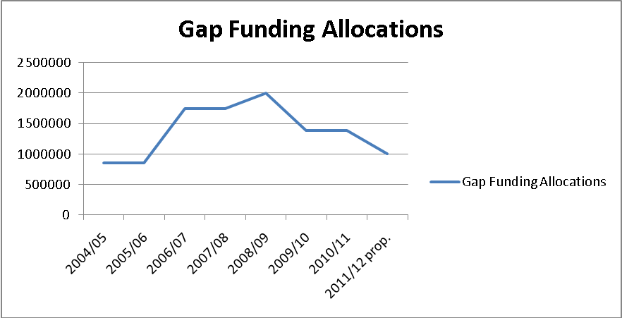

Supplemental Funding for Continuing Pivotal Gap Grants
For FY 10/11 with no Grant Call in sight, and facing the elimination of some very good programs, the committee approved supplemental funding for ten grants totaling $781,562. ACTIA also approved an extended end date for six grants that had remaining funding. As part of the process, the committee developed principles for funding which focused on successful grants that addressed important trip provision needs and/or met mobility management goals.

In early 2011, staff proposed designating funding to further extend any of the sixteen previously extended grants that met the criteria below for an additional year. On February 28, 2011, PAPCO concurred and allocated up to $1,000,000 for a year extension.

Criteria:
- Applicants must be one of the 16 extended grants from FY 10/11 and must demonstrate that the program continues to address closing gaps in services for seniors and disabled
- Applicant will be required to submit cost of operation for one year and any other funding sources available or planned for program
- Programs should meet the following categories of priority:
  - Mobility Management programs that directly increase consumer mobility – E.g. Travel Training
  - Trip Provision – Shuttles that are cost effective, lessen the burden on base programs, and provide a same-day option as part of a spectrum of services; Volunteer Driver Programs that do the same; Other programs that successfully fill an otherwise-unmet need
- Applicants will be required to submit most recent performance data (for example – number of one-way trips, unduplicated riders, consumers trained, etc.) and corresponding targets for FY 11/12
- Applicants will be required to submit plans/ideas for sustainability of funding for future operation, and/or meet with Alameda CTC staff to develop

Prior grant extension recipients were invited to apply by March 21, 2011. Staff evaluated applications for eligibility in relation to the approved criteria. Grants recommended for extension or extension and supplemental funding are detailed in Attachment 04A.

Fiscal Impacts
This recommended action will authorize extension and supplemental funding of 13 Gap Grants for $998,408. The impact of this approval is $998,408 from Special Transportation for Seniors and People with Disabilities Gap funds.

Attachments
04A Summary of Paratransit Gap Grant Extension Requests

