Transportation Capital Project Complete Streets Checklist
This checklist is designed to assist local jurisdiction staff in identifying and assessing a range of Complete Streets-related needs and opportunities throughout the capital project development process. This checklist is also intended to serve as documentation of Complete Streets-related elements and decisions, including exceptions from the adopted Complete Streets policy. This checklist is designed to be completed over three separate phases: the planning/scoping phase; the schematic design phase; and the final design phase.
In the beginning of the planning/scoping phase, jurisdiction staff will compile information about the project area and its existing conditions (questions 1 through 16). Questions 17-18 will document applicable plans, policies, and design guidance. Questions 19-24 should be completed at the conclusion of the planning phase, prior to entering into design, to document any issues, concerns, or ideas raised in conversations with stakeholders during the planning process.
In the schematic design phase, jurisdiction staff summarize the proposed design approach and elements in questions 25-27. The following questions, 28-37, relate to the proposed schematic design and should be completed at the end of the schematic design phase, prior to the project entering into final design.
In the final design phase, questions 38-45 should be answered at the completion of the final design, and provide an opportunity to document any changes from the schematic design as well as maintenance and construction considerations.
Following the completion of the checklist, agency staff should identify any items requiring follow-up discussion or further review regarding potential project changes or enhancements noted in the checklist. For Complete Streets exceptions identified through the checklist, staff should work with department leadership to ensure the exceptions and justifications are sufficiently documented and communicated to other departments and to community stakeholders.

Project Name_________________________________________________________________ Project Description/Project Type:
Project Extents: From_____________________________ To __________________________
Project Manager______________________________________________________________
Start date___________________ Anticipated construction date_______________________

Planning/Scoping Phase
Date completed ______________________

Land Use Context
- How is the surrounding land use context characterized? Please refer to the typology map (Figure 1) included in the Complete Streets Design Guidelines.
□  urban □  suburban □  rural and open space □  industrial
- What are the adjacent land uses (check all that apply)?
□ office/retail/mixed use □ parks / open space □industrial □ residential □ civic / institutional □ other_________________________________________________
- What are the major trip generators in the corridor, if any? (existing and future)
  - Schools □yes □no
  - Major employers □yes □no
  - Civic/community destinations □yes □no
  - Medium to high-density residential □yes □no
  - Senior centers/healthcare facilities □yes □no
  - Daily needs (grocery, retail, etc) □yes □no
  - Other______________________________

Modal Priority
- Based on the modal priority maps (available at: https://alameda-ctc.maps.arcgis.com/apps/View/index.html?appid=2040175145de4305a5f59c6e82ca16c7), list the modal priorities on the street (Note: omit for local streets):
Primary Study Corridor | Auto | □ First | □Second | □Other
 | Bicycle | □ First | □Second | □Other
 | Pedestrian | □ First | □Second | □Other
 | Transit | □ First | □Second | □Other
 | Trucks | □ First | □Second | □Other
Intersecting Street (if applicable) | Auto | □ First | □Second | □Other
 | Bicycle | □ First | □Second | □Other
 | Pedestrian | □ First | □Second | □Other
 | Transit | □ First | □Second | □Other
 | Trucks | □ First | □Second | □Other
- Complete Streets Exceptions: Check if any of these modes do not need to be served (if any modes are checked, include explanatory note)
□ auto □ bicycle □ pedestrian □ transit □ trucks
Note: __________________________________________________
_______________________________________________________
_______________________________________________________

Existing Facilities and Usage
- Functional classification (arterial, collector, local): _________________________________________
    - Traffic signals (number and type)________
    - On-street parking utilization (if known)
□ <25% □ 25% to 50% □ 50% to 80% □ >80%
□ not known
    - User volumes
Motor Vehicle  (AADT) | Heavy Vehicle % | Pedestrian Volumes | Bicycle Volumes | Buses / hour  (during peak hour)
    - Posted speed limit: _______ 85th percentile speed (if known):_______
    - Truck route designation, if any _____________
    - Loading zones: □yes □ no number___________
    - Are there any “unmovable encroachments” (e.g. buildings, masonry walls, etc.) in the public right-of-way? If yes, describe.
□yes □ no

    - Is there a future width line (Alameda County)? If yes, specify the width.
□yes □ no width__________
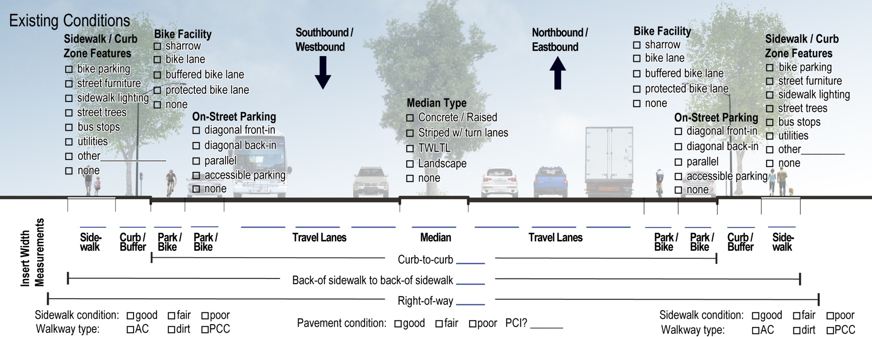

Existing Challenges
    - Safety/collision data for past five years from Statewide Integrated Traffic Records System (SWITRS) database (20_____ to 20______)
Total crashes | Fatalities | Severe Injuries | Collisions involving bicycles | Collisions involving pedestrians
      - Are any collision types over-represented?____________________
      - Are there collisions of types that may be correctable by infrastructure countermeasures? □ unsafe speeds □ left turn broadside □ failure to yield □ door zone collisions □ right hook collisions □ other_______________________________
    - Are any of the following existing challenges present in the project area?
      - Pedestrian
Striping/Crossings | □ | Low yielding compliance at midblock crossing locations
 | □ | Low yielding compliance at right turn on red locations
 | □ | Poorly marked or low visibility crosswalks
 | □ | Major trip generator or bus stop not served by crosswalk
 | □ | Wide crossing distances (e.g. greater than _____ feet)
 | □ | Intersection legs without crosswalks
 | □ | Infrequent crossing opportunities (e.g. more than ¼ mile)
 | □ | Uncontrolled crossings of high speed or high volume roadways
Signals | □ | Insufficient pedestrian crossing time
 | □ | Signal cycle lengths resulting in long crossing delay for pedestrians (e.g. cycle length of ____ sec)
 | □ | Missing push buttons
 | □ | Missing countdown signals
Sidewalk Construction | □ | Missing curb ramps
 | □ | Insufficiently sized median refuges or medians that do not extend to crosswalk
 | □ | Obstructions or “pinch points” in sidewalk clear width
 | □ | Missing sidewalks or sidewalk gaps
 | □ | Utility boxes, signage, or street furniture obstructing the natural walking path
 | □ | Lack of pedestrian-scale lighting or insufficient illumination of pedestrian realm
 | □ | Other __________________________________________

      - Bicycle
Striping/Crossings | □ | Left turns where bicyclists cross multiple lanes or merge into high speed traffic
 | □ | Unmarked door zone
 | □ | Missing bike lane striping, pavement marking, or signage
 | □ | Bike lanes on the curb side of right turn pockets
 | □ | Bike lanes between through lane and right turn pockets for greater than 200 feet
 | □ | Uncontrolled crossings of high speed or high volume roadways
Signals | □ | Insufficient crossing time 
 | □ | Missing or unmarked bicycle detection
Roadside | □ | No/insufficient bicycle parking
 | □ | Storm drains or gutter pans in bicycle lane that are not bicycle compatible
 | □ | Other __________________________________________

      - Transit
Operational | □ | Unnecessary pull-outs
 | □ | Buses experience delays pulling into traffic from stops
 | □ | Frequent bus/bike weaving
 | □ | Intersections that take multiple cycles for bus to clear
 | □ | Insufficiently wide curb lanes
Stop Location | □ | Bus stops not adequate in length to accommodate buses on route during peak hour
 | □ | Low ridership or redundant stops that could be consolidated
 | □ | Nearside stops that could be moved to farside
Stop Design | □ | Stops without benches or shelters
 | □ | Insufficient space for door landing at stops
 | □ | Higher ridership stops lacking amenities
 | □ | Other __________________________________________

      - Truck/Commercial Vehicle/Large Vehicle/Curb Management
 | □ | Frequent double parking activity
 | □ | Off-tracking into opposing travel lane
 | □ | Off-tracking onto curb
 | □ | Insufficient lane widths
 | □ | Missing or damaged route signage
 | □ | Other __________________________________________

      - General
 | □ | Slip lanes not justified by design vehicles or traffic volumes
 | □ | Driving at unsafe speeds
 | □ | Wide turning radii not justified by frequent buses or other large vehicles
 | □ | Wide travel lanes not justified by frequent transit or other large vehicles
 | □ | Vehicle volume significantly less than capacity
 | □ | Obstructed sight lines (parked cars, utility boxes, trees, vertical curves)
 | □ | Skewed intersections that can be “teed up”
 | □ | Other __________________________________________

Notes:

Plans, Policies, Guidelines, and Standards
    - Have any ongoing or existing plans identified needs in the study area?
Plan | Needs identified in Plan (e.g. crossings, turn lanes)
 | Ped | Bike | Transit | Vehicular
    - Relevant policies, design standards and guidelines
  - Complete Streets Design Guidelines
  - Complete Streets Policy Resolution
  - Others to be listed
  - Others to be listed
  - Others to be listed
  - Others to be listed
Have all applicable design standards for bicycle/pedestrian facilities been followed? □yes □ no □ partially, explain: ________________________
______________________________________________________________

External Agency/Stakeholder Coordination
(To be completed at conclusion of planning/scoping phase)
    - List agencies requiring coordination:
Agency | Has coordination occurred? Note any issues that are outstanding.
□ yes
□ no

□ yes
□ no

□ yes
□ no

□ yes
□ no

□ yes
□ no

Internal Department Coordination
(To be completed at conclusion of planning/scoping phase)
    - Note internal departments requiring coordination:
Department | Has coordination occurred? Note any priorities or concerns. If coordination has not occurred, note whether it is planned.
Community Development | □ yes  □ no
Traffic Engineering | □ yes  □ no
Road Design | □ yes  □ no
Maintenance | □ yes  □ no
Right-of-Way Services | □ yes  □ no
Other?

Community Stakeholder Review
(To be completed at conclusion of planning/scoping phase)
    - Have relevant advisory committees been informed of the project? □  yes □  no if yes, list________________________
_______________________________________________________
_______________________________________________________
_______________________________________________________
    - Have community stakeholders been engaged?
□  yes □  no
    - Have adjacent property owners been engaged?
□  yes □  no
    - Have there been public meetings? (N/A for smaller projects)
□ yes, if so, how many?_________ □ no
□ meeting(s) are upcoming on ___________________ dates
Comment themes:
_______________________________________________________
_______________________________________________________
_______________________________________________________
_______________________________________________________
_______________________________________________________
_______________________________________________________
_______________________________________________________
_______________________________________________________
_______________________________________________________

Schematic Design Phase
Date Completed ______________________

Modal Priorities
    - Do the recommended facilities for the priority modes create conflicts or tradeoffs between modes? (if yes, describe) □yes □no
_______________________________________________________
_______________________________________________________
_______________________________________________________
    - Did you omit the preferred design for a higher priority mode in place of a lower priority mode?
□ yes (if yes, which______________________) □ no
If yes, explain:

Proposed Design
    - What complete streets elements are proposed in the design?
      - Sidewalk zone □ Zone not impacted by project
- Additional marked pedestrian crossings
- Additional treatments to enhance existing crossings
- Targeted widening around obstructions to maintain minimum ADA clear path
- Relocation of fixed objects to maintain minimum ADA clear path
- Widened sidewalk for enhanced pedestrian realm
      - Curb zone □ Zone not impacted by project
- Bicycle parking
- Street trees
- Pedestrian scale lighting
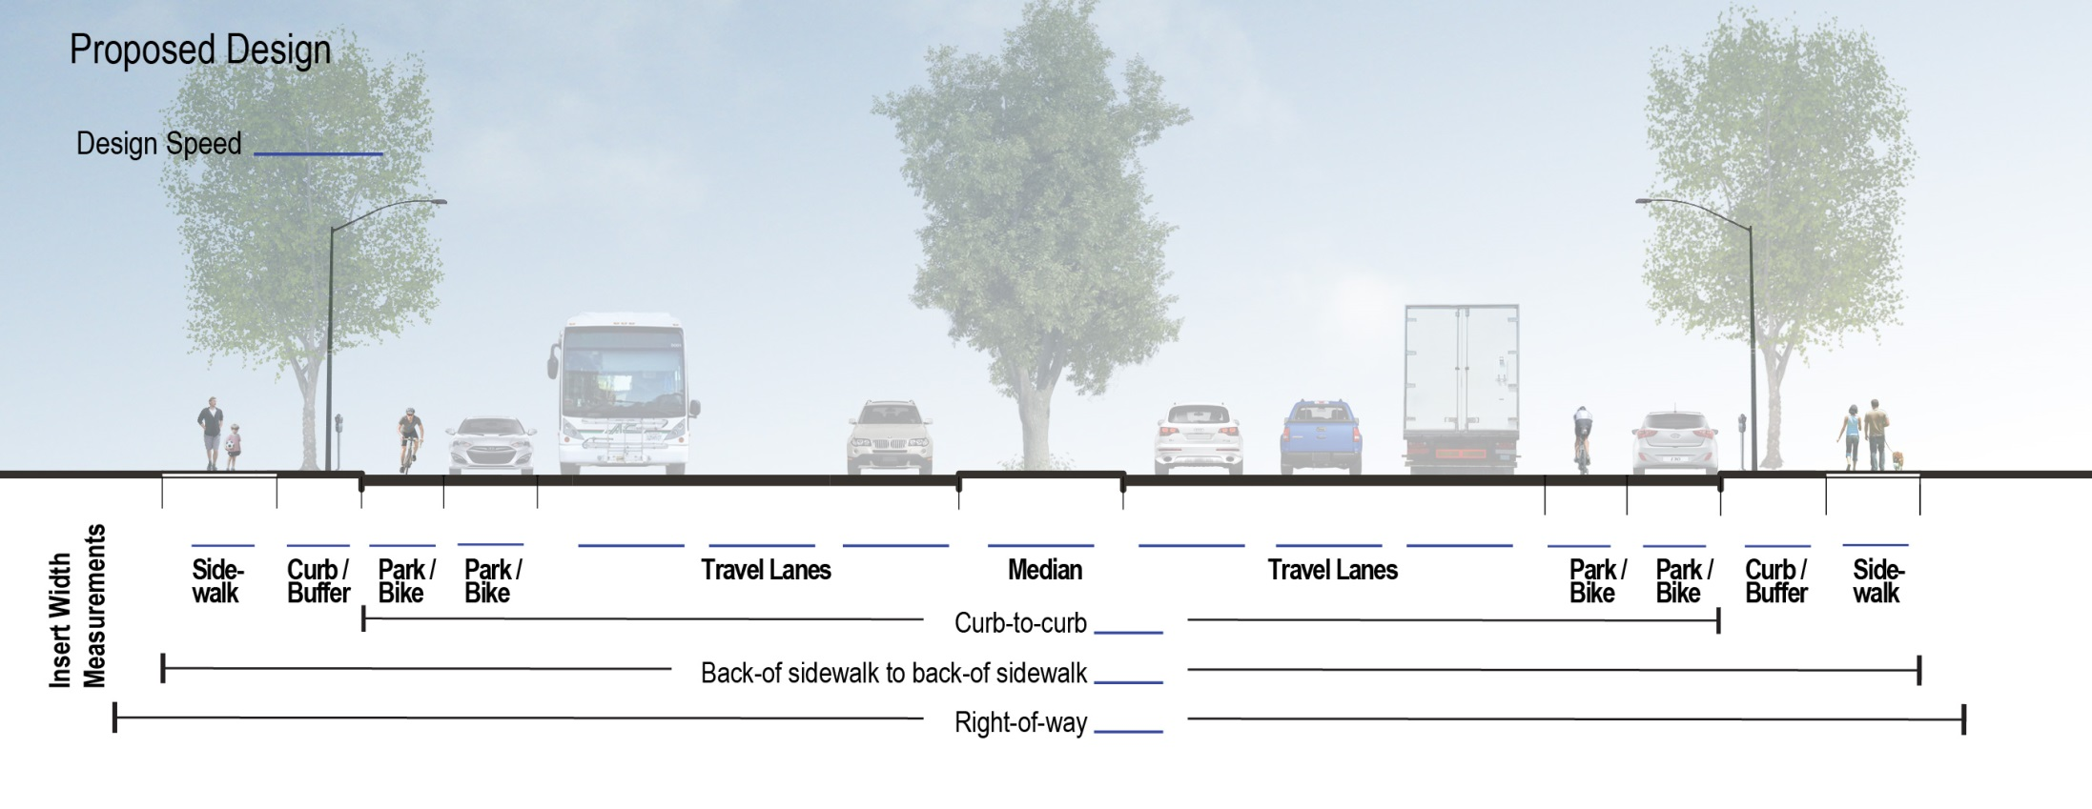
- Bus shelter/other transit stop amenities
      - Parking zone □ Zone not impacted by project
- Bike corrals
- Bus loading islands
- Bus bulbs
- Bus stop relocation/consolidation
- Bus stop lengthening
- Concrete bus loading pads
- “Daylighting” – removal of parking at intersections for improved sight distance of pedestrians
- Loading zones
- Short-term or pick-up/drop-off parking
- Curb parking (provides pedestrian buffer)
- Back-in angle parking
- Marking of parking tees/door zone for bicyclist safety
      - Bicycle zone □ Zone not impacted by project
- New Class II bike lanes
- Widened Class II bike lanes
- Bike lane buffers
- Class IV bike lanes
- Shared lane markings
- Paint to mark conflict/weaving zones
- Bicycle wayfinding
- Contraflow bike lanes
      - Vehicle zone □ Zone not impacted by project
- Narrowed travel lanes to reduce traffic speeds
- Widened travel lanes to accommodate buses or trucks
- Vertical traffic calming elements (speed bumps, speed humps/tables)
- Horizontal traffic calming elements (chicanes, edge islands, traffic circles)
- Signal coordination at slower signal progression speed
- Textured pavement for traffic calming
- Dedicated transit lanes
- Class III bike routes
- Diverters/volume management on Class III bike routes

      - Median zone □ Zone not impacted by project
- Pedestrian refuge island
- Trees or landscaping
- Left turn pockets
      - Intersections and crossings □ Zone not impacted by project
Signal Timing/Phasing | □ | Pedestrian leading interval
 | □ | Bicycle leading interval
 | □ | Pedestrian scramble phase
 | □ | Signal retiming to improve bike/ped crossing times
 | □ | Separate bicycle signal phase
 | □ | Transit signal priority
 | □ | Restriction of right turn on red
 | □ | Restriction of permitted left turns
Signal Hardware | □ | Pedestrian countdown signals
 | □ | Pedestrian push buttons
 | □ | Audible pedestrian signals
 | □ | New bicycle detection
 | □ | RRFB or pedestrian hybrid beacon
Striping / Paint | □ | Bicycle box
 | □ | Bicycle two-stage left turn box
 | □ | Bike lanes marked through intersection
 | □ | Bike lanes to the left of right-turn pockets
 | □ | Advanced yield lines or stop bars
 | □ | Recessed stop bar for large vehicle turning radii
 | □ | High visibility crosswalk
Curb ramps /realignment | □ | New or realigned midblock crossings
 | □ | ADA curb ramps – one crosswalk approach
 | □ | ADA curb ramps – two crosswalk approaches
 | □ | Curb extensions/bulb outs
 | □ | Mountable curbs to accommodate trucks
 | □ | Bus queue jump
 | □ | Realigned or rechannelized intersection
 | □ | Closure of slip lanes

External Agency/Stakeholder Coordination
(To be completed at conclusion of planning/scoping phase)
    - Have outstanding issues from planning phase been discussed further?
Agency | Has further discussion/coordination occurred? Note ongoing issues or resolutions to earlier issues:
□ yes
□ no

□ yes
□ no

□ yes
□ no

□ yes
□ no

□ yes
□ no

Internal Department Coordination
(To be completed at conclusion of planning/scoping phase)
    - Have the concerns from the planning phase been discussed further?
Department | Has further discussion/coordination occurred? Note any priorities, resolutions to earlier issues, or outstanding concerns.
Community Development | □ yes  □ no
Traffic Engineering | □ yes  □ no
Road Design | □ yes  □ no
Maintenance | □ yes  □ no
Right-of-Way Services | □ yes  □ no
Other?

Community Stakeholder Review
(To be completed at conclusion of planning/scoping phase)
    - Have relevant advisory committees been updated? □yes □no
    - Further discussion with community stakeholders? □yes □ no
    - Further discussion with adjacent property owners? □yes □ no
    - Have there been additional public meetings? □yes □ no
(N/A for smaller projects) □upcoming
    - Have there been comment themes differing from those in the planning phase? □yes □ no
Additional comment themes:

Design Tradeoffs
(To be completed at conclusion of planning/scoping phase)
    - Were any design options considered/evaluated and not recommended?

    - If the project does not incorporate separate bicycle and pedestrian facilities, list the reasons why:
□ Cost
□ Right-of-way
□ Not the first or second modal priority
□ Other
    - How does the proposed schematic design impact conditions for each mode? If negative or positive, note the impact. (Note: both negative and positive impacts could be found for one mode. Leave blank if mode not present.)
Mode | Impacts | Describe the Impact
Auto | □ positive  □ neutral  □ negative | (e.g. intersection delay; reduced on-street parking supply)
Bicycle | □ positive  □ neutral  □ negative | (e.g. increase in vehicle speeds, narrowing of bike lanes)
Pedestrian | □ positive  □ neutral  □ negative | (e.g. increase in roadway width; removal of sidewalk space; increased signal cycle lengths)
Transit | □ positive  □ neutral  □ negative | (e.g. intersection delay; removal of stop amenities)
Trucks | □ positive  □ neutral  □ negative | (e.g. intersection delay; reduction or removal of loading zones; reduce maneuverability)
Other mode (if applicable)? | □ positive  □ neutral  □ negative

Final Design
Date Completed: __________________

Modal Priorities
    - Are there potential conflicts between modes that were not addressed in the schematic design phase, and that still need to be addressed? (if yes, describe) □ yes □ no

Proposed Design
    - Are there any changes from the schematic design? Note changes below, and summarize the impacts on each mode, if applicable:
Changes:

Mode | Are there impacts from the design changes (differing from schematic design)? If so, describe:
Auto | □ yes  □ no
Bicycle | □ yes  □ no
Pedestrian | □ yes  □ no
Transit | □ yes  □ no
Trucks | □ yes  □ no

Stakeholder/Departmental Coordination
    - Have outstanding concerns been discussed further or resolved? Note how issues have been resolved and/or any issues still outstanding.
Agency/Dept. raising issue | Note ongoing issues or resolutions to earlier issues:
    - How have community comments been addressed in final design?

    - Are any major comment themes not addressed? If yes, note.
□yes □ no

Maintenance and Construction Phase Considerations
    - How will access be maintained during construction for all modes (check one box per mode)?
Agency | Auto | Bicycle | Pedestrian | Transit | Trucks
Detour for duration of project | □ | □ | □ | □ | □
Time-of-day closures only (e.g. nighttime) | □ | □ | □ | □ | □
Short-term closures (e.g. 24 hour) with detour route | □ | □ | □ | □ | □
Access maintained with reduced facilities* | □ | □ | □ | □ | □
Full access maintained (work does not impact mode) | □ | □ | □ | □ | □
Other (note): | □ | □ | □ | □ | □
*”Access maintained with reduced facilities” could mean some travel lanes closed for vehicles; could mean bicycle lane is closed, with signage for bicycles to share travel lane; could mean that sidewalk is closed with pedestrian space provided on shoulder; could mean that some transit stops are closed; etc.)

    - Which agency/department is responsible for ongoing maintenance?
  - Street sweeping and cleaning __________________________
  - Restriping and repaving _______________________________
  - Street furniture (lighting, benches, etc.) __________________
  - Landscaping_________________________________________
  - Waste receptacle and recycling pick-up___________________
  - Other______________________________________________
    - Is maintenance of the facility included in regular annual budgets? (if no, how will maintenance occur?)
□ yes □ no

MTC Complete Streets Checklist Correspondence
This checklist is designed to gather some of the same information as is requested in the MTC Complete Streets checklist. The following table shows which questions correspond to the MTC checklist. In some cases, the questions are not the same, but will help provide some information.
MTC Complete Streets Checklist Question # | Complete Streets Checklist Section or Question #
1A | Page 2, Existing Facilities
1B | Not addressed
1C | 16A and 16B
1D | 16A and 16B
2 | 3
3 | 15
4a | 17
4b | Not addressed
5a | 18
5b | 18
6 | 41
7 | 27
8a | Not addressed
8b | 36
9 | 43
10 | 44 and 45

Additional Project Notes
Potential project modifications:

Complete Streets exceptions (refer to questions 5, 26 and 38):

